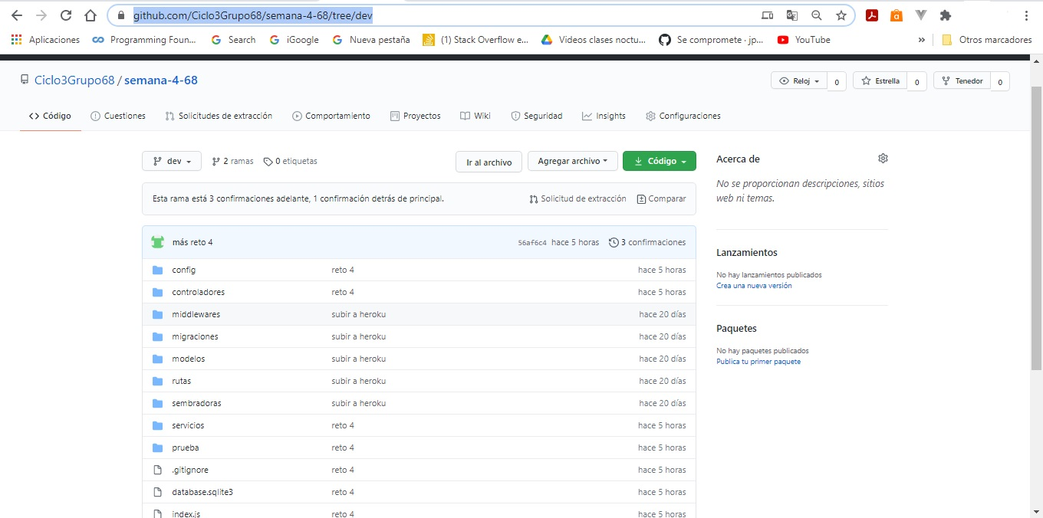

<https://github.com/Ciclo3Grupo68/semana-4-68/tree/dev>